Lab 4
FBD - BnB Angular Position Control using PID- RSLogix5000
Seth Ricks
11/13/2026
ECEN 470

Objectives
Become more familiar with Studio 5000 communication with Allen-Bradley machinery. Function Block Diagram (FBD) programing by creating a control system to interface with the Ball and Beam (BnB) machine.
Control the BnB on the spectrum of -45$°$ to 45$°$. Achieve a working system whose specifications meet the following requirements:
- Rise time, $t_{r}≤0.5s$
- Percent Overshoot, $M_{p}≤5\%$
- Settling time, $t_{s}≤0.7s$
- Steady-state error, $e_{ss}≤3°$

Task 1:
- Use Factory Talk to properly connect to the Allen-Bradley controller, using the IP-address inscribed on the casing.
- Create a new program and discover backplane modules.
Task 2:
- Set threshold voltages of the I/O analog cards, to protect terminal cards and BnB.
- Set sample rates for proper control and verification of the BnB.
Task 3:
- Send test voltage for motor speed, to verify proper connection with the BnB
- Receive potentiometer voltages to verify proper outputs of the BnB
Task 4:
- Find the corresponding voltage values for the following degrees: -90$°$, -45$°$, 0$°$, 45$°$, 90$°$
- Use a scaling block to convert voltage to angle, and angle to voltage
Task 5:
- Implement proportional controller.
- Test values of $K_{p}$ and observe the output of the BnB
Task 6:
- Implement integral controller.
- Test values of $K_{i}$, and observe the difference in the BnB.
Task 7:
- Implement derivative controller
- Implement LPF
- Test values of $K_{d}$, and observe the difference in the BnB.
- Scale degrees back to voltage for the BnB motor input
Task 8:
- Tweak the values of $K_{p}, K_{i}, and K_{d}$to meet requirements
Task 9:
- Pass off lab with instructor, create demonstration video and GitHub repository.

Procedures

Equipment and supplies
- A school computer with Studio 5000 and FactoryTalk installed, and an Allen-Bradley CompactLogix controller.
- Ball and Beam (subsequently referred to as BnB)

Task 1:
The first thing that needed to be done was connect to the Allen-Bradley controller. After connected, we also had to add and uninhibit the slots on the controller. This was done in the same manner as the previous labs.
We also needed to create a new Function Block Diagram program and make it the main path file. To do this, the original main needed to be deleted and replaced with this new program.

Task 2:
To protect the motor of the BnB, we set voltage clamps of the output analog card. We set this to 10.2 to -10.2 volts, and can be seen in Figure 1 below.
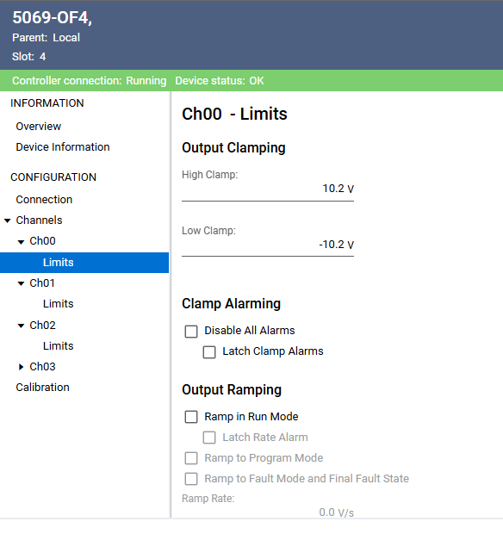
Figure 1: Threshold Analog Output Voltages

For the input card, we want to sample at a fixed rate. We made the period of this sample 1 ms, which is sufficiently small to see if the system is following the given requirements. This is included in Figure 2 below.

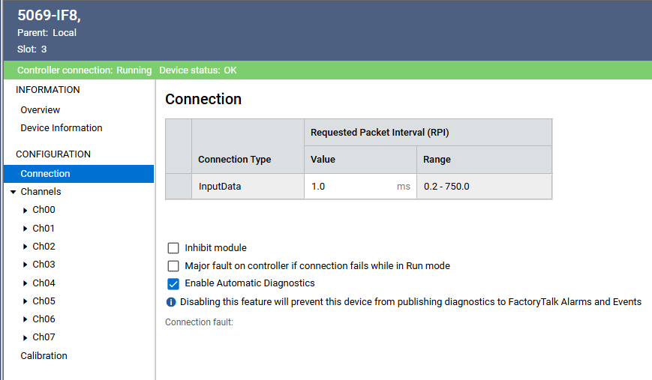
Figure 2: Setting Sample Rates

Task 3:
For this task, we needed to ensure that we were properly connected to the BnB. This proved to be more difficult than expected, as it seemed that the controller was not responding. When we sent input voltages, the BnB would not respond, and when we moved the gear manually we did not get a proper voltage reading on the tags. This issue turned out to be something that the rest of the class was struggling with as well. The solution to the issue was frustratingly simple: a ground wire. There was a stray ground wire on the connection cable, that needed to be connected to ground. This was not readily apparent, as the lab instructions did not include this wire clearly. An image of the cable is included as Figure 1. The cable is a slight blur of grey on the left side, circled in red.
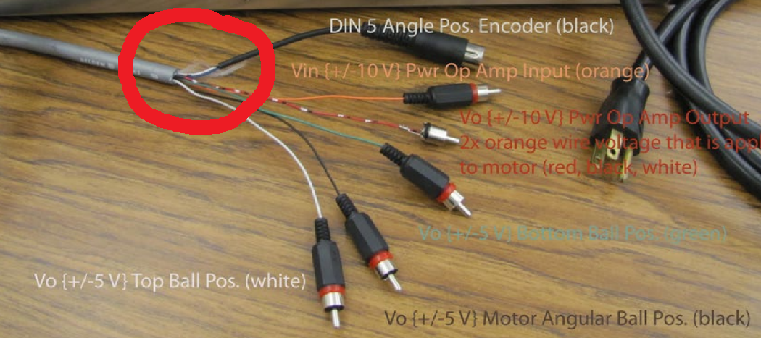
Figure 3: Stray Ground Wire

After the ground wire issue was resolved, interfacing with the BnB was straightforward. There were two tasks that we needed to accomplish, to make sure that we could communicate with the BnB effectively. The first was sending a test voltage to control the motor speed, from the controller to the BnB. The second was reading the output of the potentiometer as a voltage, sent to one of the tags on our controller board. We were able to successfully accomplish both.
The input to the controller, namely “MotorVoltageInt” (even though this is a reading from the potentiometer), is the tag referencing analog input card #3, and the data of Channel 0. The output of the controller, which controls the speed of the motor of the BnB, is similarly referenced by the alias “MotorInInt,” and is referencing the analog output card #4, and the data of Channel 0. The tags for these two voltages can be seen in Figure 2.
Figure 4: Voltage I/O Tags

By manually turning the gear on the BnB, as highlighted in Figure 3, we were able to change the potentiometer voltage value indicated by ‘MotorVoltageInt’. Similarly, we confirmed that changing the value of the tag ‘MotorInInt’ changed the speed of the motor. The first is on a scale of -5 to 5 volts, and the second is on a scale of -10 to 10 volts.
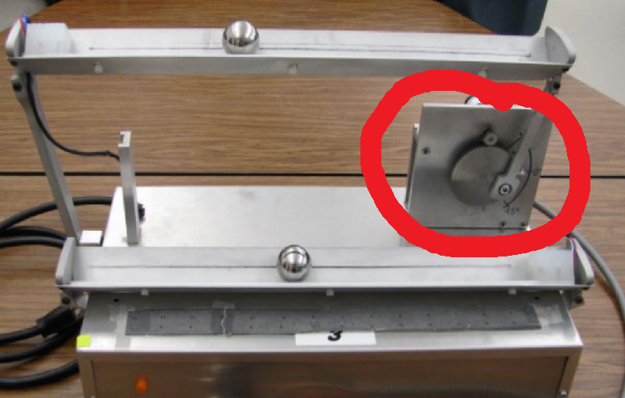
Figure 5: Ball and Plate, Gear Highlighted

Task 4:
Once we had confirmed that we could properly communicate with the BnB, we had to do some tuning before writing the actual controller logic. This is because each of these machine is slightly different, with different centers and values for degrees. We found the voltage values from the potentiometer for -90$°$, -45$°$, 0$°$, 45$°$, and 90$°.$ We then used a scaling block to convert voltage to angle. The properties table for this scaling block is shown in Figure 4. This block maps the values of InRawMax/InRawMin to InEUMax/InEUMin. In this particular case, as can be seen in the figure, the voltage input values of 3.8 to -19.2 are mapped to 90.0$°$ to -90$°$. We determined these values from the values we measured manually, shifting appropriately to account for the off-center zero degree value.
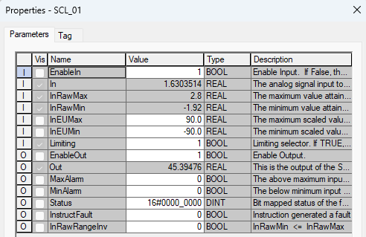
Figure 6: Scaling Block Parameters Table

Task 5:
Now that we had the values of the motor mapped appropriately from the input voltages, we could start the controller logic. The first and simple thing that we did was implement a proportional controller, which is just a multiplication block. However, before going into this block, we subtracted the desired motor angle from the actual measured motor angle, to find the error. The parameters of the subtraction block are simple but can be seen in Figure 5. Source A is the desired motor angle, while source B is the actual. The difference between them is the error.
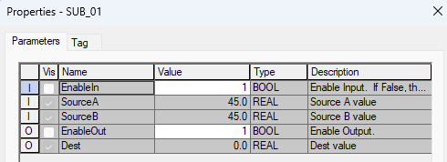
Figure 7: Subtraction Block Parameters Table

The error is then passed into the multiplication block, which effectively is the proportional controller. The parameters for the multiplication block can be seen in Figure 6 below. The most important part of this is Source A, which represents $K_{p},$ which is the proportional gain. Something that we noticed when we ran this code, was that the angle of the BnB wouldn’t settle on a value. It simply oscillated around the desired input value. We also noticed that higher values of $K_{p}$ made the process of reaching the desired value faster but resulted in larger oscillations. We experienced that making the proportional gain too high resulted in the system going unstable, with the oscillations larger than the radius of the gear.
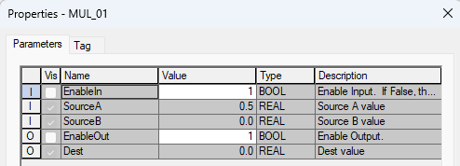
Figure 8: Multiplication Block Parameters Table

Task 6:
After successfully making the proportional controller, we decided to add an integral controller. This consists of taking the same error signal from Task 5 (which was from the difference of the desired vs actual motor angles) and passed it in parallel to an integral block. The parameters for this block can be seen in Figure 7 below.
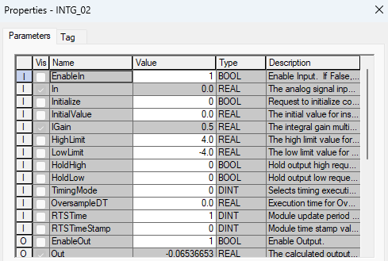
Figure 9: Integral Block Parameters Table

We found that the integral controller was most useful when dealing with steady state error. This means that if the BnB settled on a motor angle without oscillating around it, but it still wasn’t the desired motor angle, we could adjust the integral gain to fix this. The integral term of a PID controller looks at the area of the error curve over time, and so it applies a change to fix something that is slightly off for a long period of time, which is the definition of steady state error.

Task 7:
After making and successfully implementing the PI controller, we moved on to including a derivative term in the design. We found that this can have fatal consequences, if not done carefully. This is because the derivative term of a PID controller amplifies noise, as it takes the change of the error over time and adds it to the result. This can be helpful, as we can change the dynamics of our system. But it can also be deadly if applied in too generous of portions or use inconsistently. The parameters for our derivative block can be seen in Figure 8.
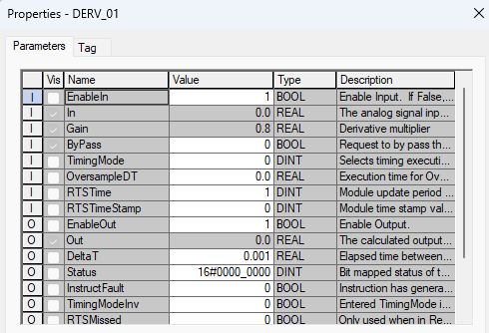
Figure 10: Derivative Block Parameters Table

As mentioned, the derivative block amplifies errors. Because of this, it is necessary to include a lowpass filter. This filter will take unnecessarily large amplifications in noise and filter them out, leaving the design with a more controllable derivative term. The parameters for the low pass filter can be seen in Figure 9. We chose a WLag of 0.5, which allows frequencies below 0.5 rad/s to pass through the system with little to no attenuation. This aids us in our error amplification issue. The before and after of the LPF signal can be seen in Figure 10 below.
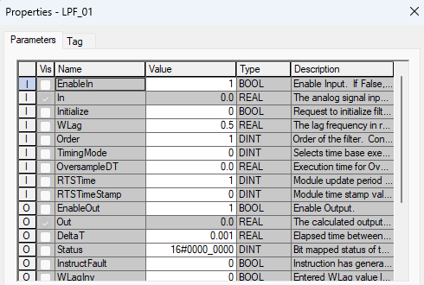
Figure 11: Derivative Block Parameters Table

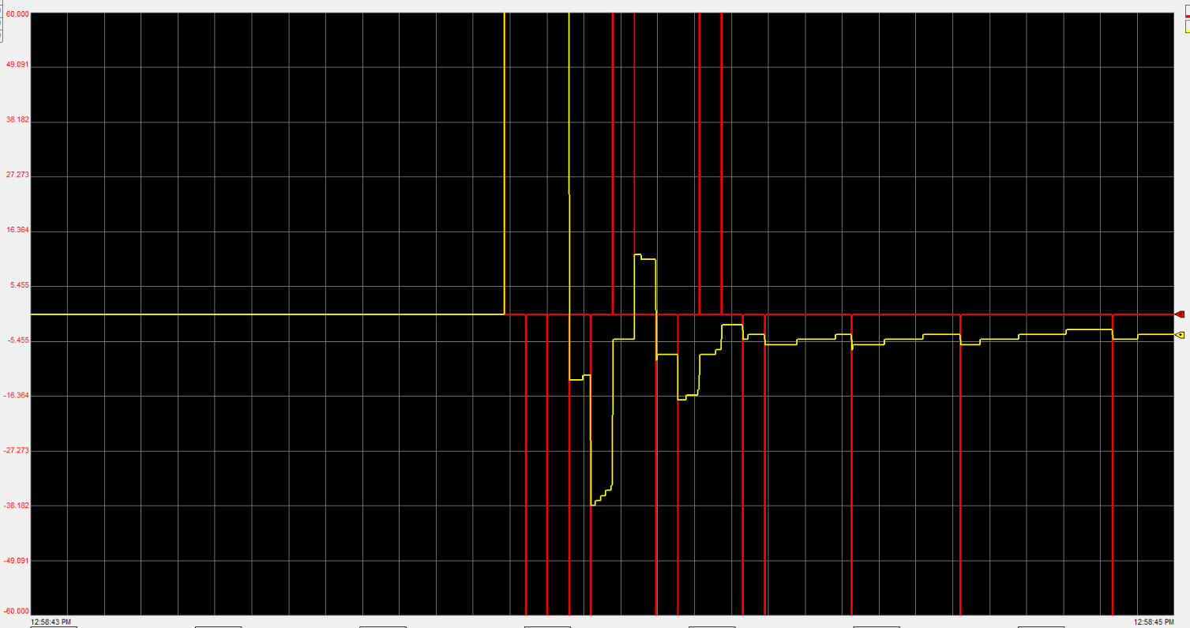
Figure 12: Low Pass Filter

To incorporate all of the different elements of the PID controller together, we had to use a simple summation block. This block really just sums together the different values coming from the proportional, integral, and derivative/LPF terms, but for consistency the properties table is included in Figure 11.

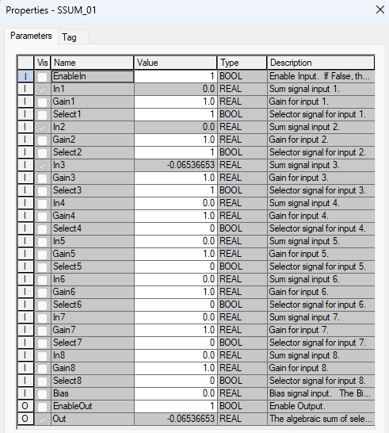
Figure 13: Summation Block Parameters Table

After summing these terms together, the output is in degrees. This is the value in degrees that we want to command the motor to go to. However, as you may recall, the BnB doesn’t take values in degrees, it takes voltage. Because of this, it is necessary to include another scaling block, to do the opposite of the first- map the angle to degrees. The parameters for this block are included in Figure 12 below. The include taking the raw desired angle input, which in this case is -90 to 90 degrees, and mapping it to the voltage that the BnB takes: -10 to 10 volts.
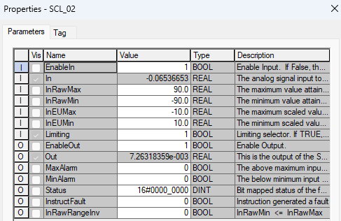
Figure 14: Second Scaling Block Parameters Table

The entire layout of the Function Block Diagram can be seen in Figure 13 below. It is essentially a PID controller, with some mapping done before and afterwards, and a low pass filter after the derivative term. Appropriate comments are included to help understand the code.
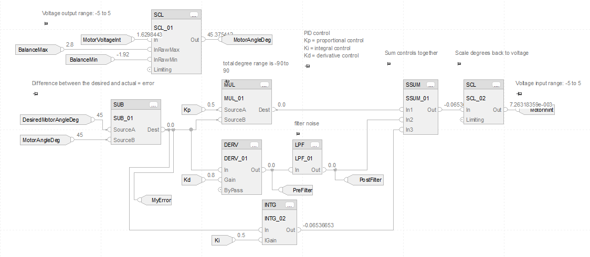
Figure 15: Function Block Diagram Code

Task 8:
As previously mentioned, we were given the following requirements that we had to meet:

  - Rise time, $t_{r}≤0.5s$
  - Percent Overshoot, $M_{p}≤5\%$
  - Settling time, $t_{s}≤0.7s$
  - Steady-state error, $e_{ss}≤3°$
To meet these requirements, we had to play with our proportional, integral, and derivative gains to see how it affected the system. At times, we met three of the requirements but missed one of them. For example, the following graph, Figure 14, demonstrates what the output looks like, when going from 0 to 45 degrees, when the parameters are $K_{p}$=1, $K_{I}$=4, $K_{d}$=0.1. This graph meet the rise and overshoot specifications, but did not meet the settling time. We theorized that this was because the integral term was so large, but we decided to tweak everything as well.

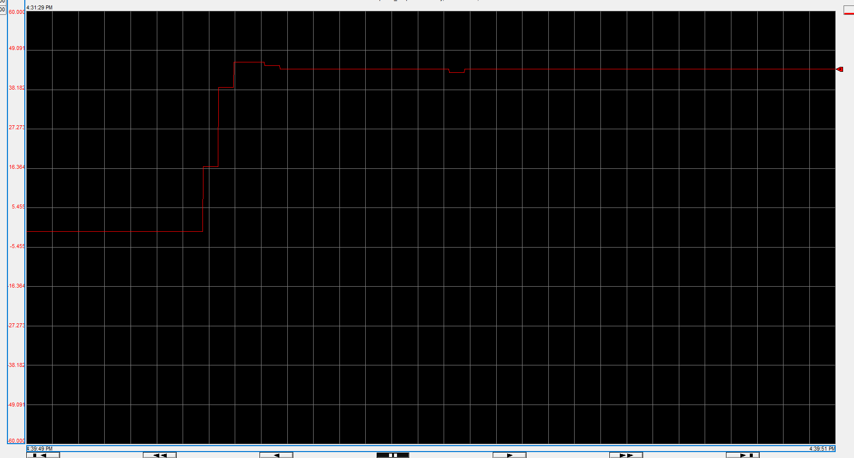
Figure 16: Attempt at Tweaking PID Gains

We were finally able to hit values of the gains that met all of the specifications, which is shown in Figure 15 below. These values were: TODO
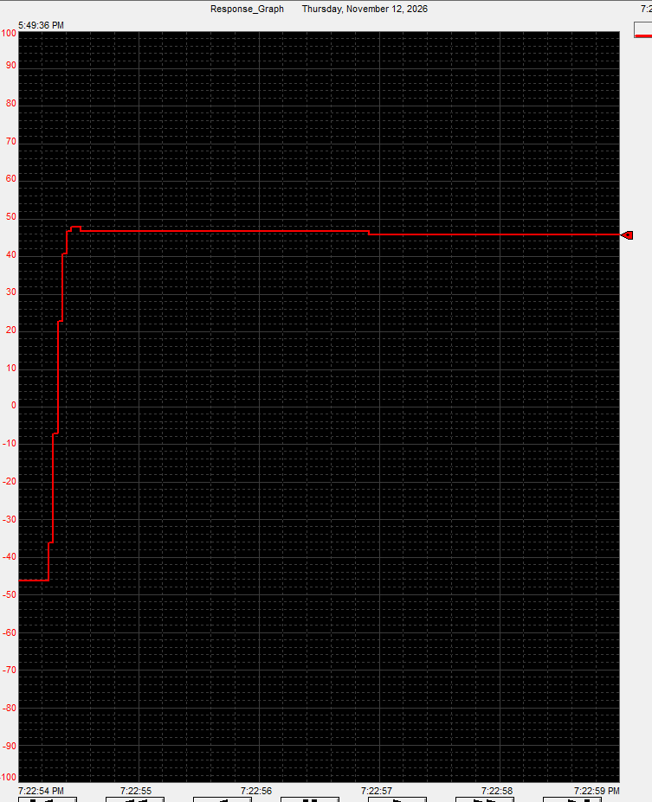
Figure 17: Successful Response Graph

TODO: graph not good, and need to annotate/explain it
Task 9:
To ensure proper functionality of the machine, this project was passed off with the instructor.
Follow this link to see a demonstration of the lab: Lab3 Demonstration Video
To ensure our code wasn’t wiped from the school computer, we saved a version of it on GitHub. Follow this link to see the code for this project: Lab3 GitHub

Conclusion:



